Constructive Rest / Passive Alignment / 90-90 Position
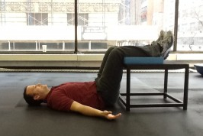
This exercise (as seen below) has been called many different things and has been claimed to be an innovative technique by many different people. But the truth is that people have been putting their feet up at the end of the day long before any clinician could coin it as their own. While each individual may have a different rationale and name for this exercise, the principle and basis are the same regardless.
The world's easiest postural restoration exercise (aka 90-90 position, constructive rest, static back)

Rationale
- Allows for passive re-alignment of spine and posture (Pete Egoscue)
- Decreases the tension of the psoas muscle to allow for “constructive rest” (Liz Koch)
- Puts the low back in the position of the least load on the discs
- Reduction of lumbar lordosis
- Increases the posterior separation between the vertebrae and facet joints
- Reduces pressure on the nerves

How to Perform
- Lie on ground
- Put feet up (on an ottoman, chair, coffee table, dog, significant other, etc.)
- Make sure your hips and knees are at 90-90
- Aim for 15-20 minutes per session
- Enjoy

Cognitive Connection
Many practitioners advocate conscious awareness of your body in this position (e.g. where do you feel pressure? tension? stress?). Some believe this is also a great position to exercise your diaphragmatic breathing. Others recommend simply focusing on allowing your body to relax and to let your body adapt to gravity. Try a combination of these approaches to find what works best for you.
90-90 Position, Constructive Rest Position, Egoscue Static Back

Source: http://www.aaronswansonpt.com/constructive-rest-passive-alignment-90-90-position/

